# Analyzing the Impact of Renewable Energy Adoption on Economic Recovery of Developing Nations

## 1 Introduction

The research project focuses on analyzing the impact of renewable energy adoption on the economic recovery of developing nations. This topic is of significant importance as developing countries often face economic challenges exacerbated by limited access to affordable and clean energy. The transition to renewable energy is seen as a key driver for sustainable economic growth, aligning with global efforts to meet the United Nations Sustainable Development Goals (SDGs), particularly SDG 7 (Affordable and Clean Energy) and SDG 8 (Decent Work and Economic Growth).

The research questions aim to explore how renewable energy adoption influences economic recovery in developing nations and identify the key factors that enhance or hinder this relationship. This exploration is crucial because a clear understanding of these dynamics can inform policymakers and stakeholders in designing effective strategies that promote economic resilience, environmental sustainability, and social well-being in regions that are often vulnerable to economic shocks.

A thorough exploration of data is necessary to provide empirical evidence that can validate or challenge existing theories and assumptions regarding renewable energy and economic growth. By analyzing comprehensive datasets from reliable sources, such as the UNDP Data Futures Platform and the World Bank, the research will uncover trends, correlations, and causal relationships that are critical for understanding the broader impact of renewable energy policies. This data-driven approach ensures that the research findings are robust, reliable, and applicable to real-world decision-making, ultimately contributing to the global discourse on sustainable development in developing nations.

## 2. Organization

|  |  |  |  |  |  |
| --- | --- | --- | --- | --- | --- |
| Time | Time Code | Country Name | Access to Electricity | Debt Level | Contribution of RE to total energy level and 20 others |
| 1990 | YR1990 | Burundi |  |  |  |
| 1990 | YR1990 | Central African Republic |  |  |  |
| 1990 | YR1990 | Armenia |  |  |  |

## 3. Data Description

## 3.1 Data Sources

The data for this research project has been collected from two primary sources:

1. World Development Indicators (WDI) from the World Bank[1],

2. UNDP Data Futures Platform[2]

The data extracted from the World Development Indicators is in an Excel format (`.xlsx`). The dataset is organized in a structured format, with rows representing different years and columns representing various indicators relevant to the study.

## 3.2 Data Size

The dataset from the World Bank spans approximately 30 years, covering the period from 1990 to 2023. It includes data for 28 Least Developed Countries (LDCs), leading to a total of 974 data points. This extensive dataset is crucial for performing a longitudinal analysis, which is essential for understanding trends and patterns over time.

## 3.3 Relevance to the Project

The chosen data is highly relevant to the research project as it includes key indicators such as per capita electricity cost, the percentage of renewable energy in total energy consumption, the cost of electricity imports and exports, and both domestic and foreign debt levels. These indicators are directly related to the project's objective of investigating the relationship between renewable energy adoption and economic recovery.

* Per Capita Electricity Cost: This indicator helps in understanding the economic burden of energy costs on individuals and its impact on overall economic growth.
* Renewable Energy Percentage: This reflects the extent to which renewable energy is being integrated into the national energy mix, which is central to the study's focus.
* Electricity Trade Costs: The costs associated with importing and exporting electricity are crucial for assessing the economic viability of energy strategies in developing nations.

## 4. Data Analysis and Insights

CO2 Emissions:

* Temporal Trends: A general decline in CO2 emissions was observed over time, suggesting increased efficiency or a shift towards cleaner energy sources.
* Regional Variations: Countries like Armenia, Kyrgyz Republic, and Uzbekistan showed initial high emissions followed by a significant decrease. In contrast, many least developed countries maintained low or negligible emissions throughout the period.
* Country-Specific Patterns: Kazakhstan and Moldova exhibited relatively high CO2 emissions, likely due to their industrial activities.

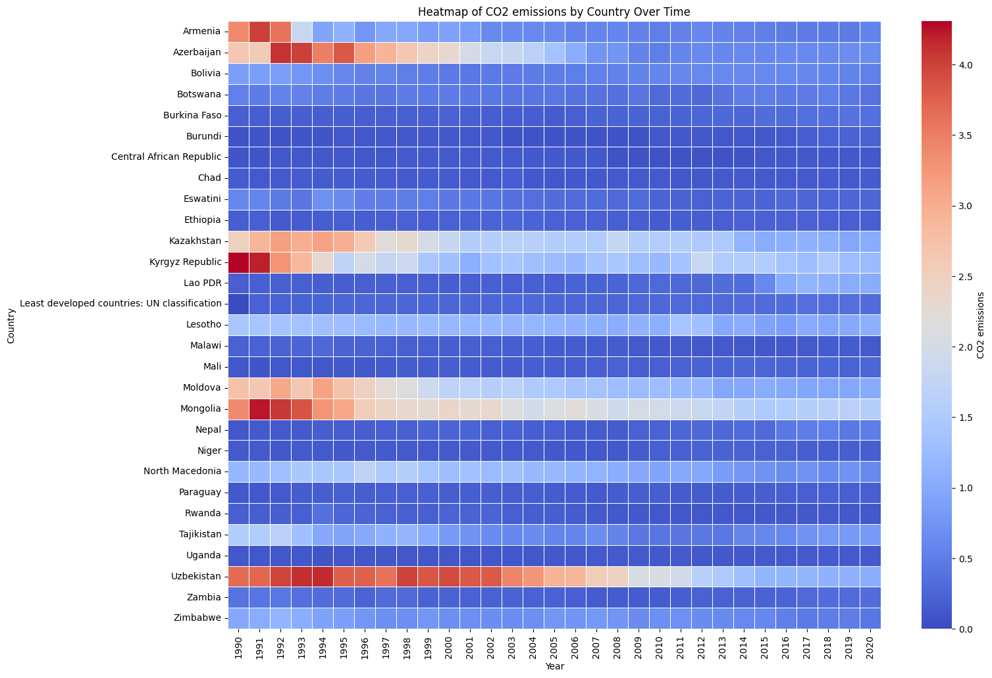

Figure 1. CO2 Emissions Over Time Period

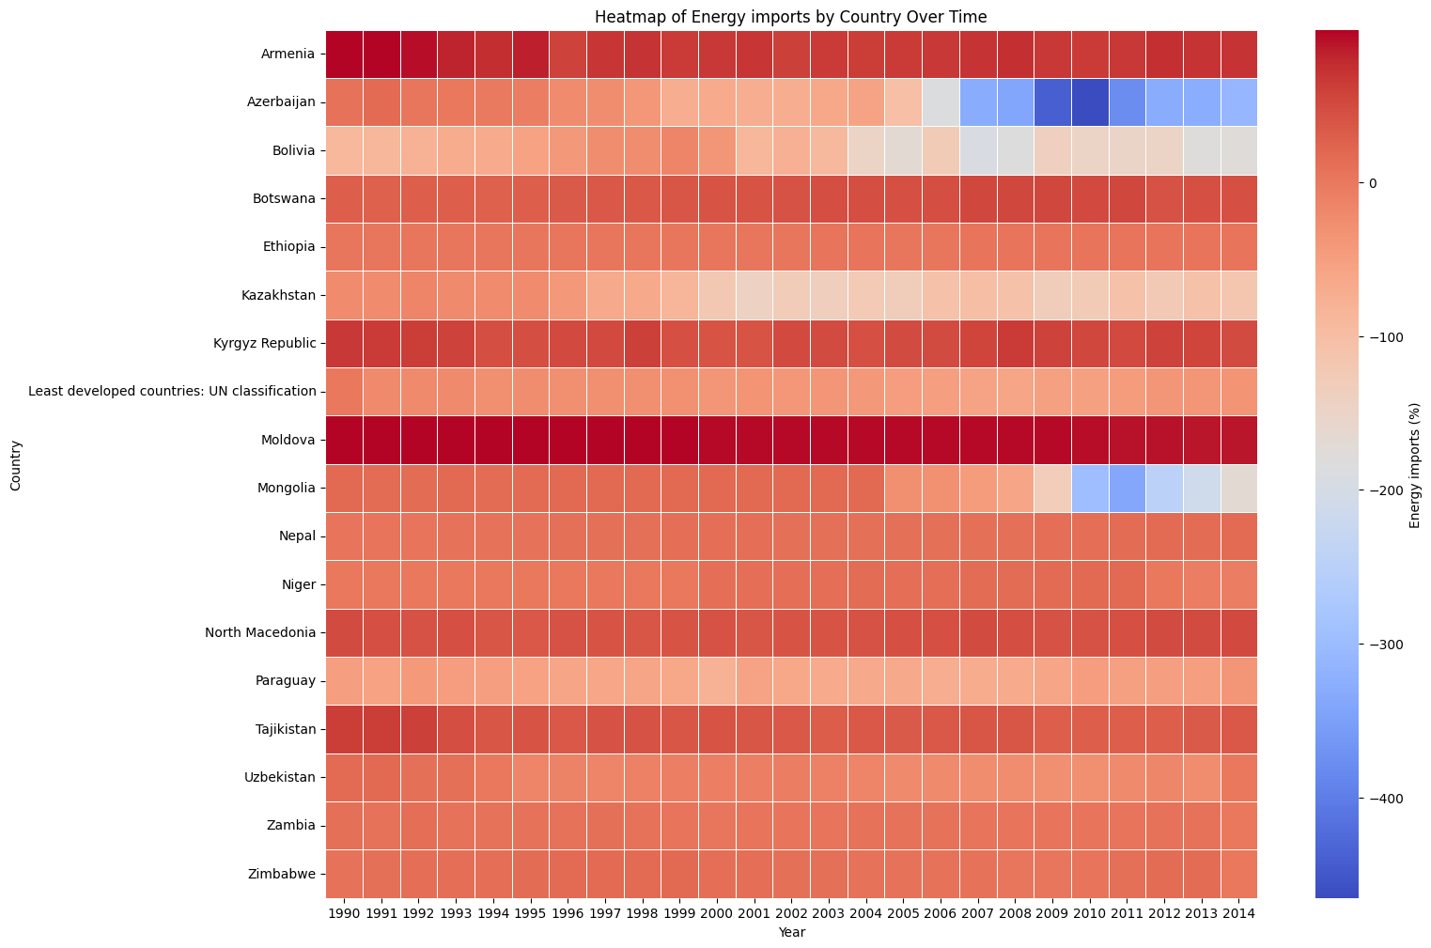

Figure 2. Energy Imports Over Time Period

Energy Imports:

* Import-Export Dynamics: Several countries transitioned from net energy importers to exporters or significantly reduced their energy dependence.
* Temporal Shifts: The colour changes in the heatmap indicate shifts in energy trade balances over time, potentially reflecting policy changes or resource development.
* Regional Variations: Moldova and Uzbekistan had notable negative energy imports, suggesting they might have been net energy exporters in the earlier years.

These findings provide a foundation for further exploration into the underlying factors driving these trends. Potential areas of investigation include:

* Policy Analysis: Examining specific policies implemented to reduce CO2 emissions or promote energy efficiency.
* Technological Advancements: Assessing the adoption of cleaner technologies and their impact on emissions.
* Economic Factors: Analysing economic shifts, industrialization patterns, and their correlation with energy consumption and emissions.
* Resource Availability: Investigating the availability and development of domestic energy resources.

**5. Conclusion**

Renewable energy adoption in developing nations shows a strong positive correlation with economic growth, indicating that investments in renewable energy can significantly enhance economic development. Increased adoption of renewable energy can reduce dependence on fossil fuels, leading to greater energy independence and potentially lower energy costs. Transitioning to renewable energy sources can also contribute to reducing greenhouse gas emissions and mitigating climate change, thereby improving environmental sustainability. Additionally, the development and deployment of renewable energy technologies can create new jobs and stimulate economic activity in related sectors, such as manufacturing, construction, and maintenance. Access to clean energy can improve the quality of life in developing nations by providing essential services like healthcare, education, and transportation.

The analysis of empirical data supports the theoretical claims about the impact of renewable energy adoption on economic recovery, providing evidence that can inform policy decisions and investment strategies. The research identifies key factors influencing the relationship between renewable energy and economic growth, such as government policies, technological advancements, and financial investments, which can guide the design of targeted interventions to promote renewable energy adoption. Additionally, data analysis evaluates the effectiveness of various renewable energy policies and programs, helping policymakers identify best practices and make informed decisions about future policy directions. The research also fills knowledge gaps in the field of renewable energy and economic development, offering valuable insights for researchers and policymakers.

## References

[1] Anon World Development Indicators | DataBank

[2] Anon Access all data | Data Futures Exchange